***CubeSats for Earth Exploration***

Rigorous investigation of Earth’s changing climate by satellite technology will benefit from more equitable access to currently hard-to-reach tools. The development and scale of small satellite technology for educational use has proven to be an important step in the democratization of climate exploration and discovery. Notably, ‘cube satellites’ (CubeSats) have emerged as an invaluable tool for rigorous characterization of phenomena related to both deep space discovery and Earth-specific climate science.

In this two-day workshop, learners will experience a crash-course in spacecraft mission design (systems engineering), build, deployment, and data analysis. Teams will build mock 3U Cube Satellites carrying with microbits. In the process, they will learn to tell meaningful stories using data, while acknowledging the rigor and challenges associated with satellite design.

DAY 01.

* *DATA LITERACY.* Analog spreadsheet discussing data, mapping with geospatial data presentation and exercise (storytelling using timelapse, open-source satellite data)

DAY 02.

* *SPACECRAFT DESIGN.* 1U CubeSat Prototyping (cardboard model + microcontroller/camera), structural testing, and programming
* *CUBESAT LAUNCH.* CubeSat deployment on tethered balloon; troubleshooting; data acquisition; Data processing and preparation
* *SHARE OUT.* Presentation; what do our data/images tell us?

Tentative Schedule:

Day 1 Schedule:

*Data Literacy*

9:30-9:45 mins

*Ice breaker (analog spreadsheet) and intro to events of the day*

20 mins

*Interactive Discussion*: **Introduction to Satellites and Geospatial Data**

25 mins

*Student Activity - turning radio into pictures*

10:15AM - 10:30AM

*Break*

10 mins

*Lecture*: **Geospatial Data Analysis and Visualization**

25 mins

*Student Activity - storytelling with satellites*

25 mins

*Presentations & group analysis*

**Day 2 Schedule:**

CubeSat Design

[*presentation* [*HERE*](https://docs.google.com/presentation/d/16cKbRKF5LuL2nJwXDH_s35NG6rTh2d11zGWdXw1u6qE/edit?usp=sharing)]

9:30AM - 9:35AM

*Ice breaker (something with space?) and intro to events of the day*

9:35AM - 9:50AM

*Lecture*: **Introduction to Space Missions and CubeSats**

9:50AM - 10:05AM

*Student Activity : draw a space patch*

10:05AM - 10:15AM

*Share out :* **Space Patches**

10:15AM - 10:30AM

*Break*

10:30AM - 10:55AM

*Student Activity :* **Build a CubeSat**

10:55AM - 11:15AM

*Student Activity :* **Test CubeSat sensors in classroom**

11:15AM - 12:00PM

*Student Activity:* **Balloon launch of CubeSats**

---------

**Day 2- Detailed Lesson Plan.**

The goal of today’s activities is to introduce what satellite missions can be used for and to highlight the uses of new cube satellites in opening accessibility to space.

[slide 1]

First pose questions on the slide and see what the students think! 

The satellite *Sputnik* was the first object that humans successfully launched into orbit, done by Russia Fall of 1957. Since then, there have been thousands (about 8,100) that have been launched with around 2,000 currently active and in orbit. For most of its history, satellite design has been expensive and difficult, with almost all satellites being built by experts in industry, academia, and government agencies. But things are changing!





[slide 2]

As the field has expanded, so has the range of satellites that are available for people to implement. While most satellites are large and designated for geolocation, communications networks, surveillance, and research, technology has been getting smaller and cheaper! This allows for diverse and riskier payloads, more room for experimentation, more specified missions, and opens access to many more people to get involved in the process!

[slide 3]

Play [video](https://www.youtube.com/watch?v=HZMiJ_Q47qk) and discuss

[slide 4]

Let’s go deeper into what makes a cubesat unique among satellites! These cubesats are quicker to build, but have a shorter lifespan. They have standardized bodies and sizes but are more experimental with their payloads. They can be linked together to form a constellation instead of just one satellite. They do not usually add to space junk! They can be made and deployed by hobbyists, universities, private companies, and governments (much more accessible than traditional satellites). Can students name some examples of missions that could be best suited for a CubeSat?



[slide 5&6]

Let’s discuss how to go further into the components of a CubeSat that need to be designed. They are:

* *Mechanical* - consists of things like the body and the hardware of the cubesat (and making sure everything can fit in the small space!)
* *Radio communication* - Radio communication is how a satellite communicates with the ground (earth) and how it sends information it has collected down to earth! (remind students of activity from Day 1 of translating the beeps to the image)
* *Power and electrical* - deal with methods of harvesting and storing energy for the satellites (there are no outlets to plug into while floating in space)
* *Software and data handling* - deals with the programming that connects all of these systems and also can be used to program different protocols to execute depending on the environment to make sure that the cubesat is prepared for all situations and works smoothly during its mission.
* *Payload* - deals with what the job of your satellite is (testing a new system or device in space environment, a camera, a chemical sensor, a reaction chamber, etc)

[slide 7&8]

Examples of CubeSat projects that have been built and deployed!

[Project 1](https://www.polyu.edu.hk/web/en/media/media_releases/index_id_6174.html): The first CubeSat that was launched in September 2015 and designed by the Hong Kong Polytechnic Institute. “The objective was to monitor ground images, space particles and chamber environment. The designed life span of "Kaituo-1B" is three months. It is expected that "Kaituo-1B" will de-orbit eight years later and return to the atmosphere without creating any space debris.” The goal is for this microsatellite technology will simplify the procedures and reduce the costs of future space research experiments.

[Project 2](https://www.youtube.com/watch?v=P_8ZEAPrrHQ): [video on MARCO satellites]

[slide 9]

Activity 1: *Design a mission patch*

Mission patches are an important part of space culture and give the public on Earth an idea of the projects that are being deployed in space. Based on what we have just discussed, have students theorize a CubeSat mission that will collect data of their choosing about Hong Kong and then design the mission patch for it. The patch could give a sense the people who are designing the mission but always must give over the goal of the mission!

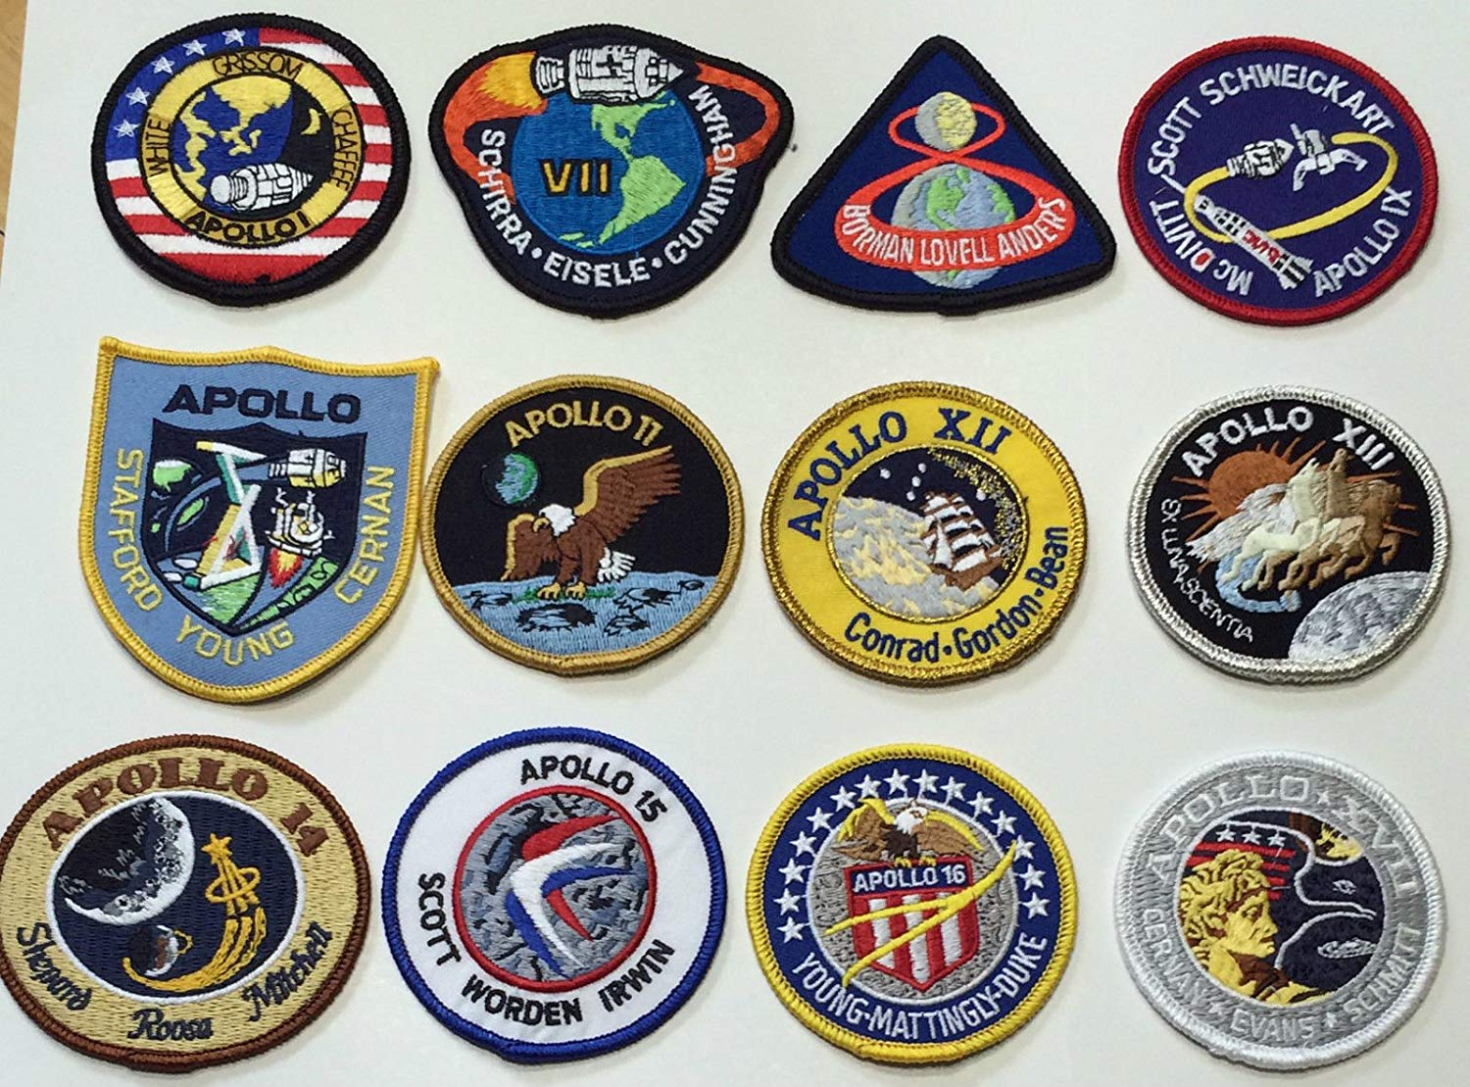

[Here](https://docs.google.com/document/d/1rG76S4Dp5wo4IBtwd4BRpmOue77NfZHP_egBfo9fqOw/edit?usp=sharing) is a template for a print-out for the patch circles!

It is important to leave time to go around the room and have students show off their patch and give a short description of what they drew and why. This share-out allows the class to hear about the different interests and concerns their fellow students have as well as provides a broader picture of how satellites could be useful. *If students seem to be stuck in a rut, remind them of the satellite data their saw yesterday and see if it helps them think more creatively!*

[*BREAK*]

After completing this activity and the break, we will start our CubeSat build!

[slide 10]

Activity 2: *Build a CubeSat*

CubeSats are affordable and available to a range of people from hobbyists to researchers because of their standardization and open design. The goal of this activity is to get students exposed to the Microbit device, do basic cardboard construction, and start playing with sensors and sensor data to see how cubesats can be used in space!

There will be four steps to this activity:

*Step 1:* Build the CubeSat

*Step 2:* Program the microbits

*Step 3:* Test the sensor systems

*Step 4*: Launch CubeSats

[slide 11]

*Step 1:* Build the CubeSat

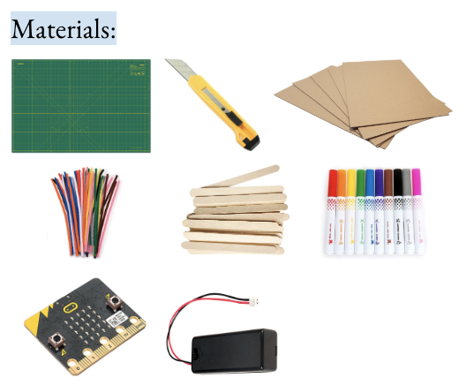

* Show students the materials they will be using to build the 10cmx10cmx10cm satellites (let them know that in reality, CubeSats can be any multiple of this but for now we will be building a single unit, also known as a 1U satellite).
* Let them know that accuracy is critical, and test this by making a “locker” that the CubeSat will go into to make sure it is launch-ready. Also make sure they leave a space inside for the microbit to go inside.
* They can decorate with the crafts, as well as do structural reinforcements with popsicle sticks. They can also put their space patches onto one of the faces of the CubeSat
* MAKE SURE STUDENTS MAKE A METHOD OF ATTACHMENT FOR THE BALLOON! This could be a reinforced loop, a popsicle stick or pipe cleaner set up, etc!

[slide 12&13]

*Step 2:* Program the microbits

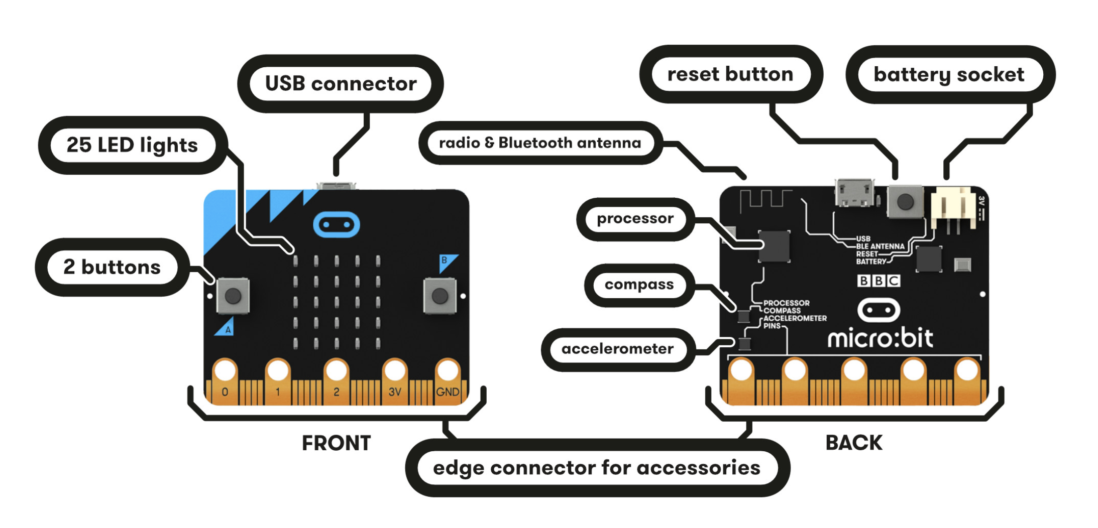

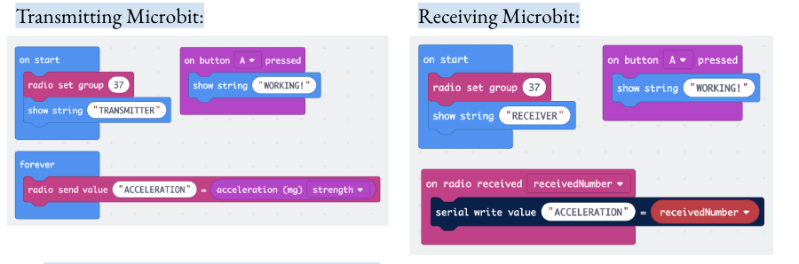

* Make sure to emphasize that keeping the code simple (for now) allows the microbits to spend more of its resources on the data collection and transmission.
* Because the code is so simple, students can write a few scripts and be encouraged to test out multiple sensors on the microbit as they get used to it.
* Assign radio groups to each group to make sure that students aren’t using the same group (could cause issues)
* Make sure that the radio sending and receiving pieces of the program stay as they are (no extra strings being outputted in the loops) or else it slows down the data acquisition.

*Step 3:* Test the sensor systems

* Put the transmitting microbit inside the CubeSat and test the sensor you have programmed!
  + Acceleration: Shake it!
  + Light: Use your hands or go closer and farther from a light source
  + Temperature: Use your hands or go closer and farther from the heat lamp
* Make sure students have the console open to see the data being collected and sent over in real time and have them think about what the data is and how it could be useful!

[slide 14]

*Step 4*: Launch CubeSats

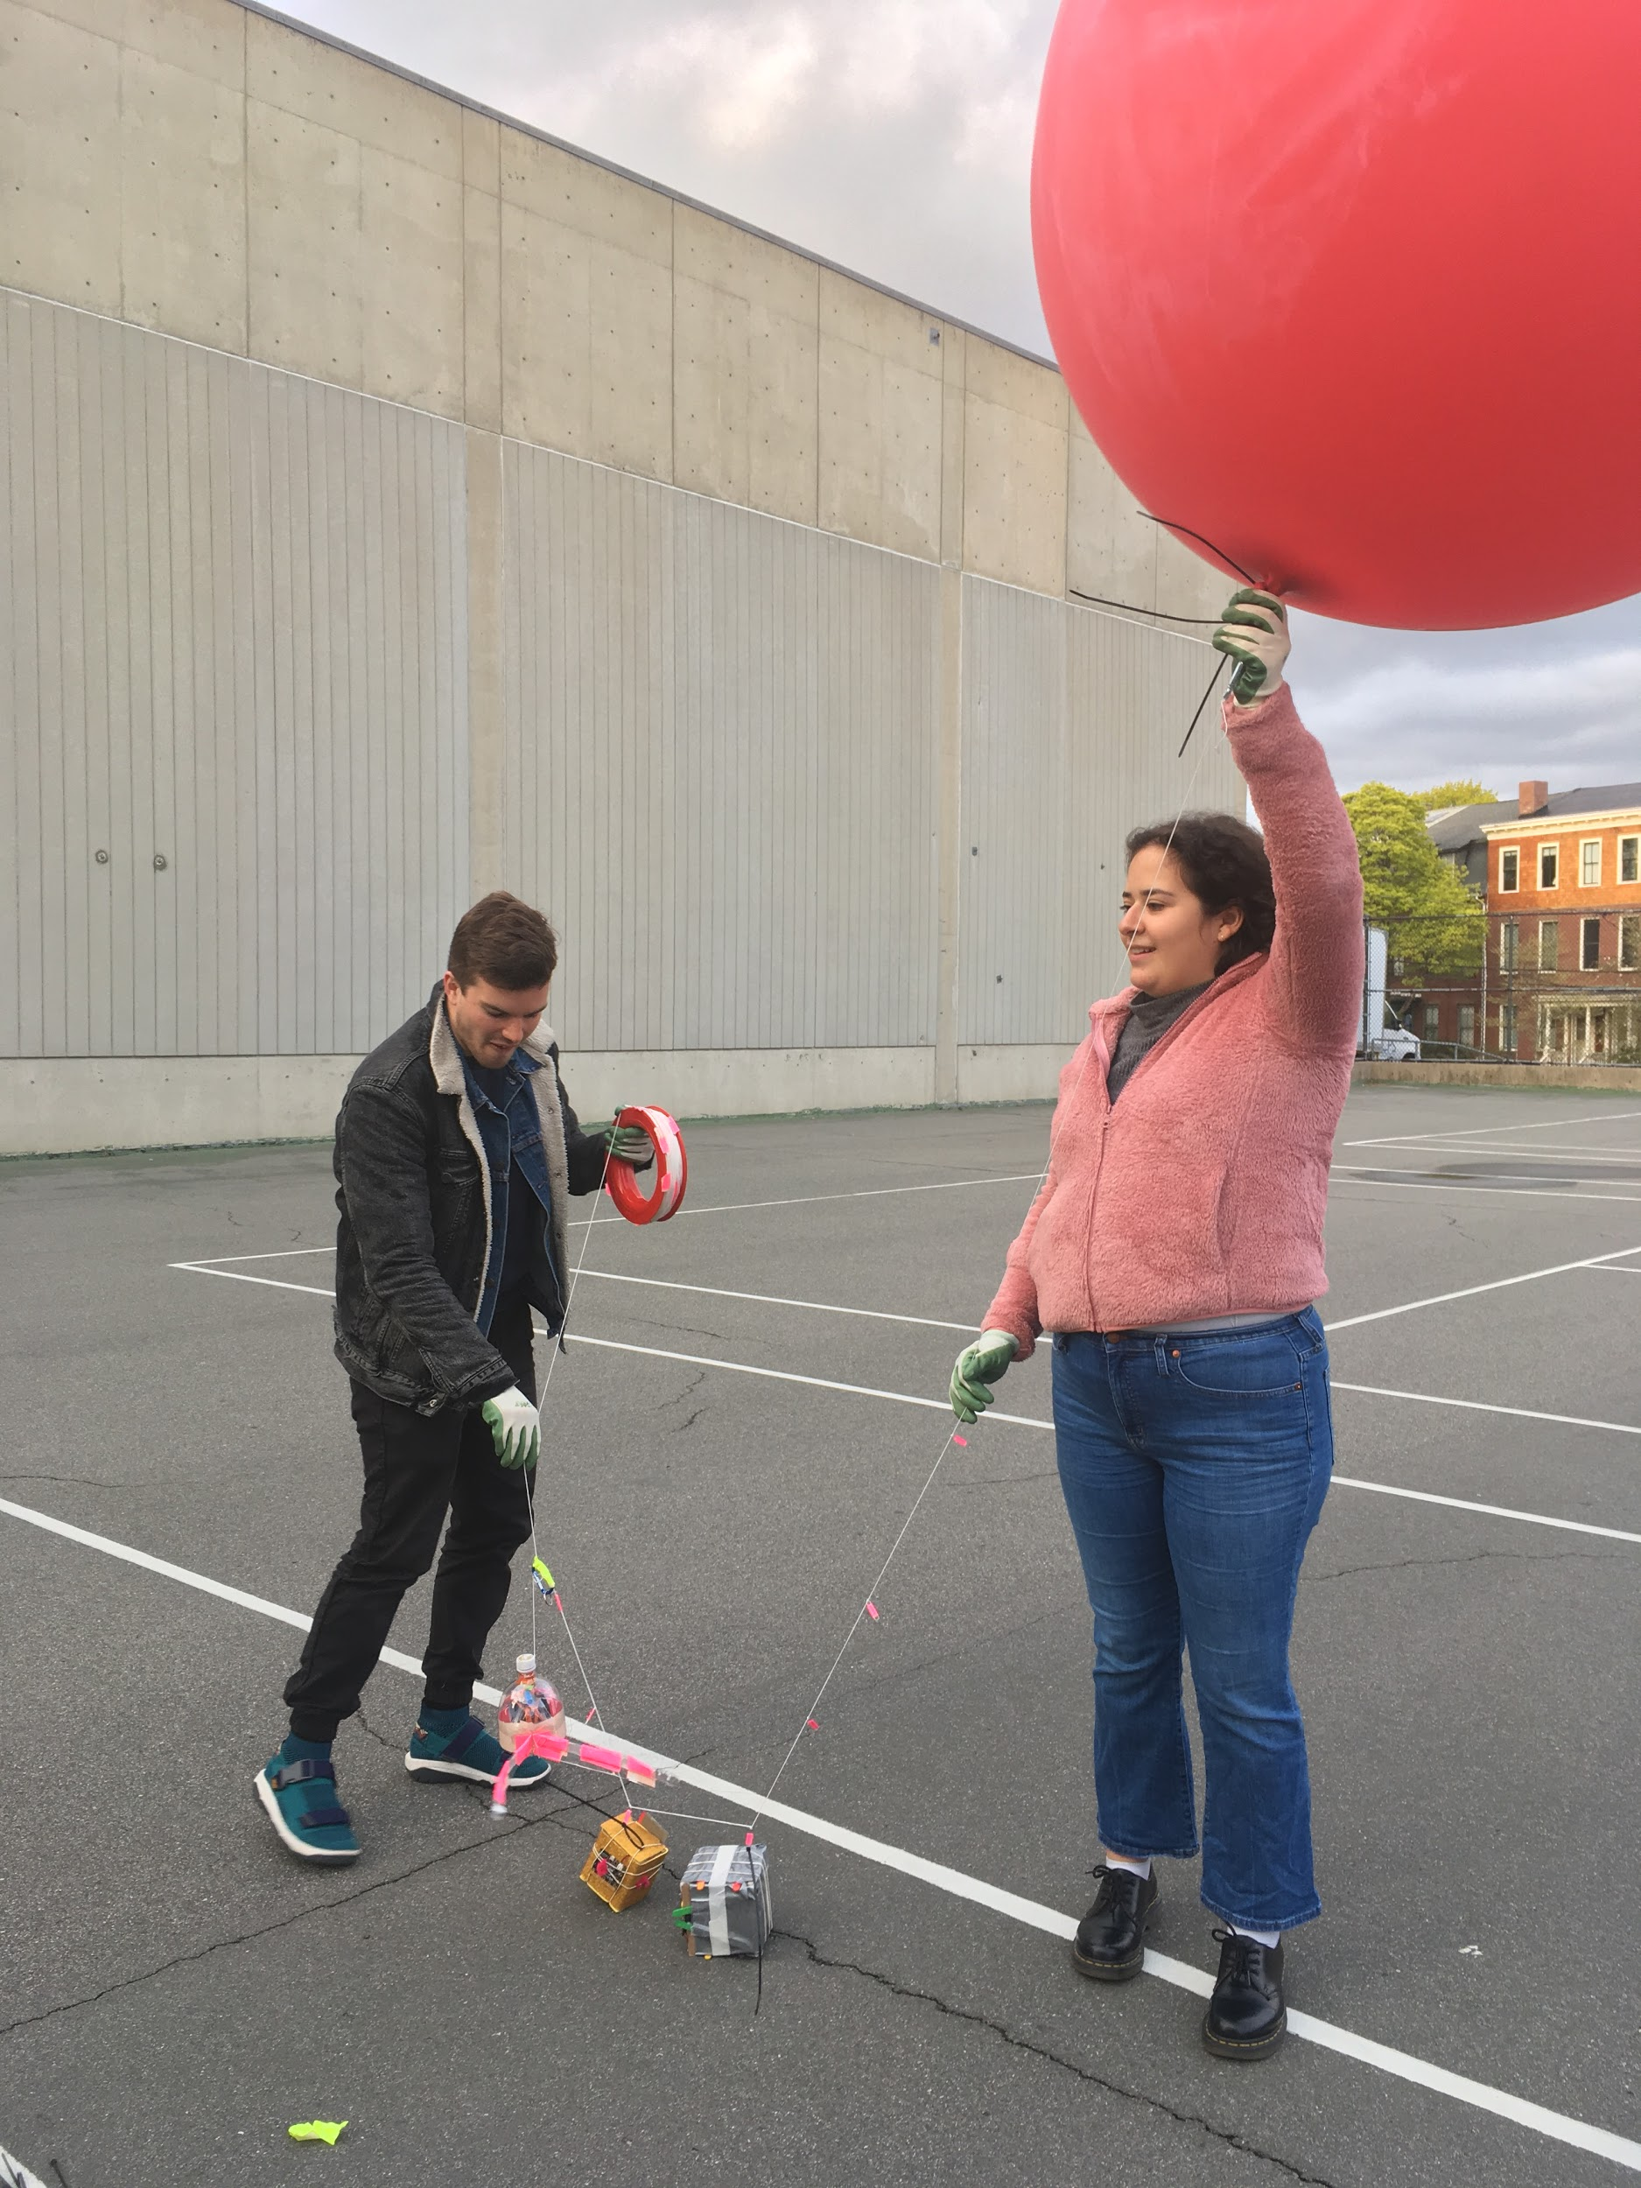

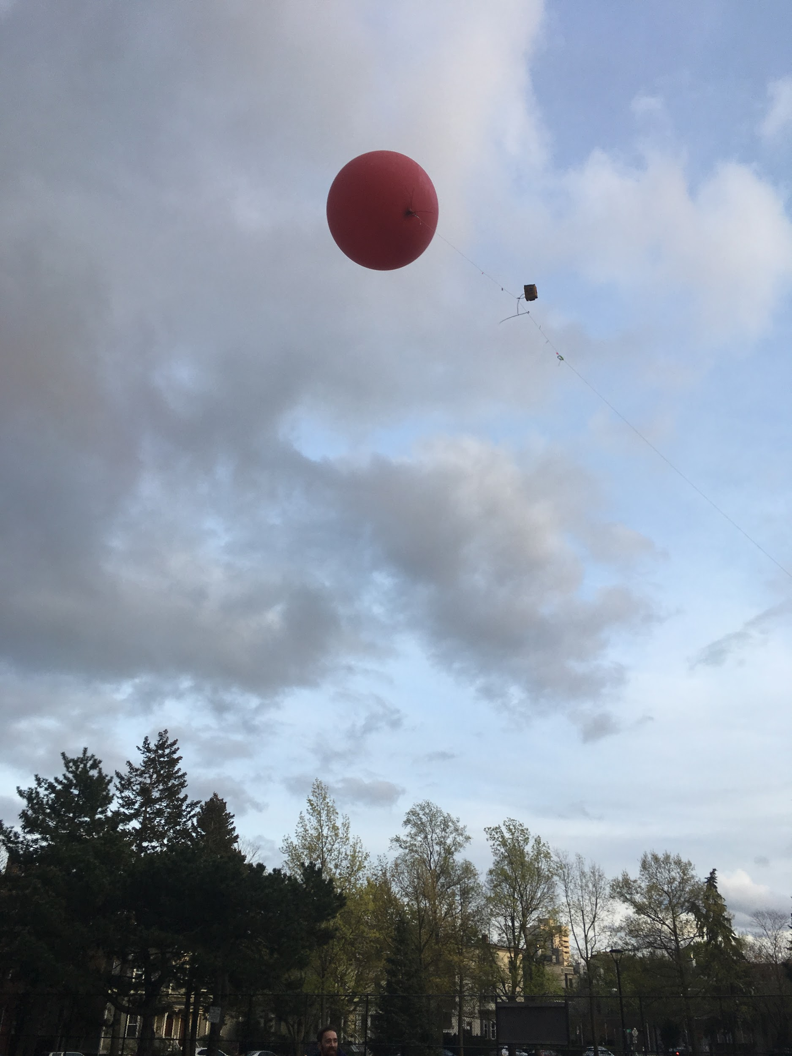

* We will launch the CubeSats on on a balloon ([see kit and instructions)](https://store.publiclab.org/products/balloon-mapping-kit?variant=7028822724) to test for design, weight, and sensor system functionality!
* Make sure the balloon has at last 50 cubic ft of helium to assure it will be able to easily lift the CubeSats. Attach them to the string by taping a paper clip to the string and then using a zip tie to attach the loop on the CubeSat to the paperclip.
* Make sure there is a computer with the receiving microbit present to pick up the data and have students be watching to see it come in and monitor any issues or changes.
* Do not spend more than 3-5 mins on any one team’s CubeSat (not enough time!)

Answer any other question and thank students for a great day!

-----

Micro:bit step-by-step guide to connect:

**Step 1:** Plug in the micro:bit to the computer using the USB port

**Step 2:** Open up the coding space (<https://makecode.microbit.org/>)

**Step 3:** click on “New Project” to start a new file

**Step 4:** drag the coding blocks from the left into the workspace to program your micro:bit

**Step 5:** Program the transmitting micro:bit

1. Make a piece of code to test that the file gets loaded (ex: an image or string appearing on the screen if the ‘A’ or ‘B’ button is pressed)

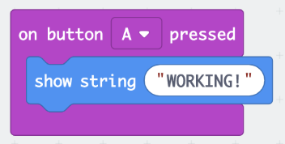

1. Make a piece of code that establishes the radio group that the sensor information will be transmitted through (it is important that every student group choose a different group to work on) as well as an optional string that will let you know upon starting up your micro:bit that it is the transmitting micro:bit

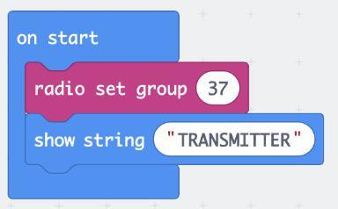

1. Make a piece of code that will be collecting and sending out the sensor information of your choice (acceleration, light, and temperature and good ones) through the radio group

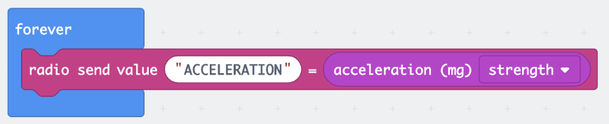

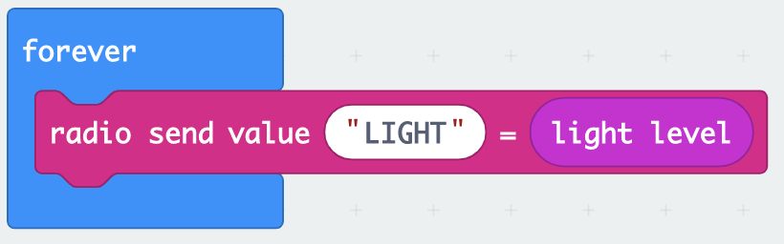

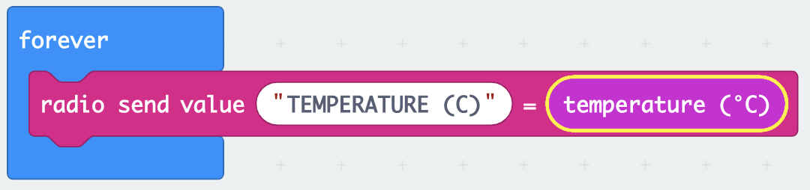

**Step 6:** Save this file with a name you will remember below the coding area

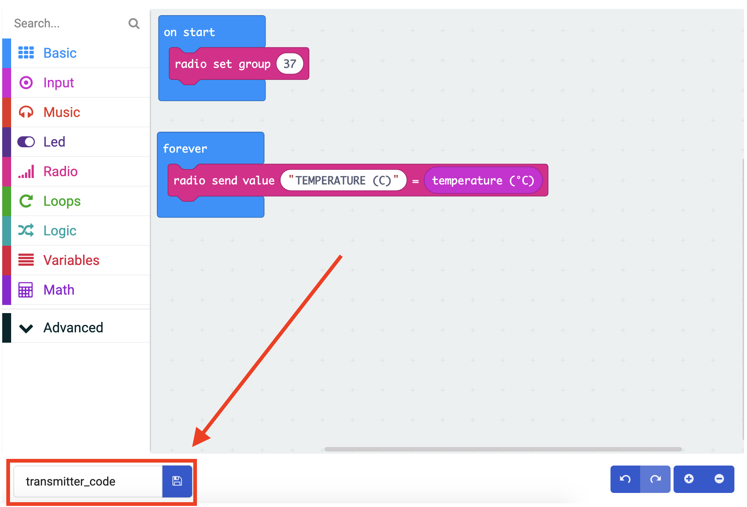

**Step 7:** Download and flash the file to the micro:bit

1. 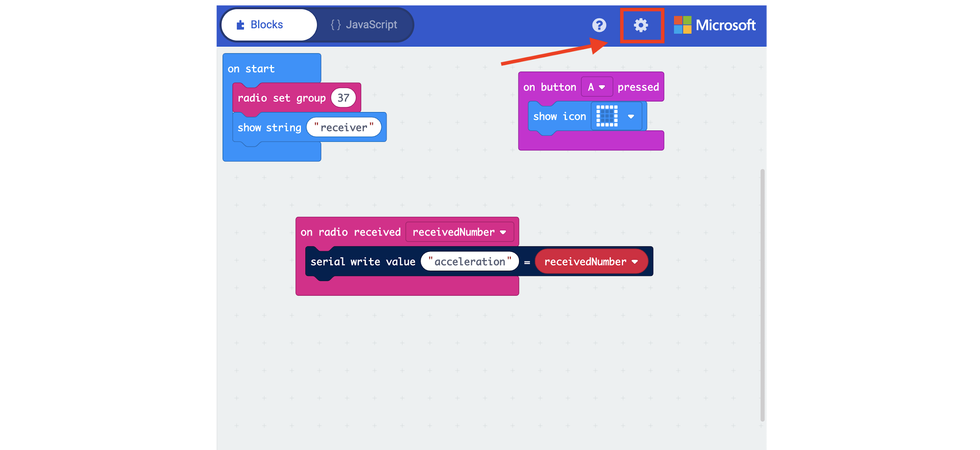
2. 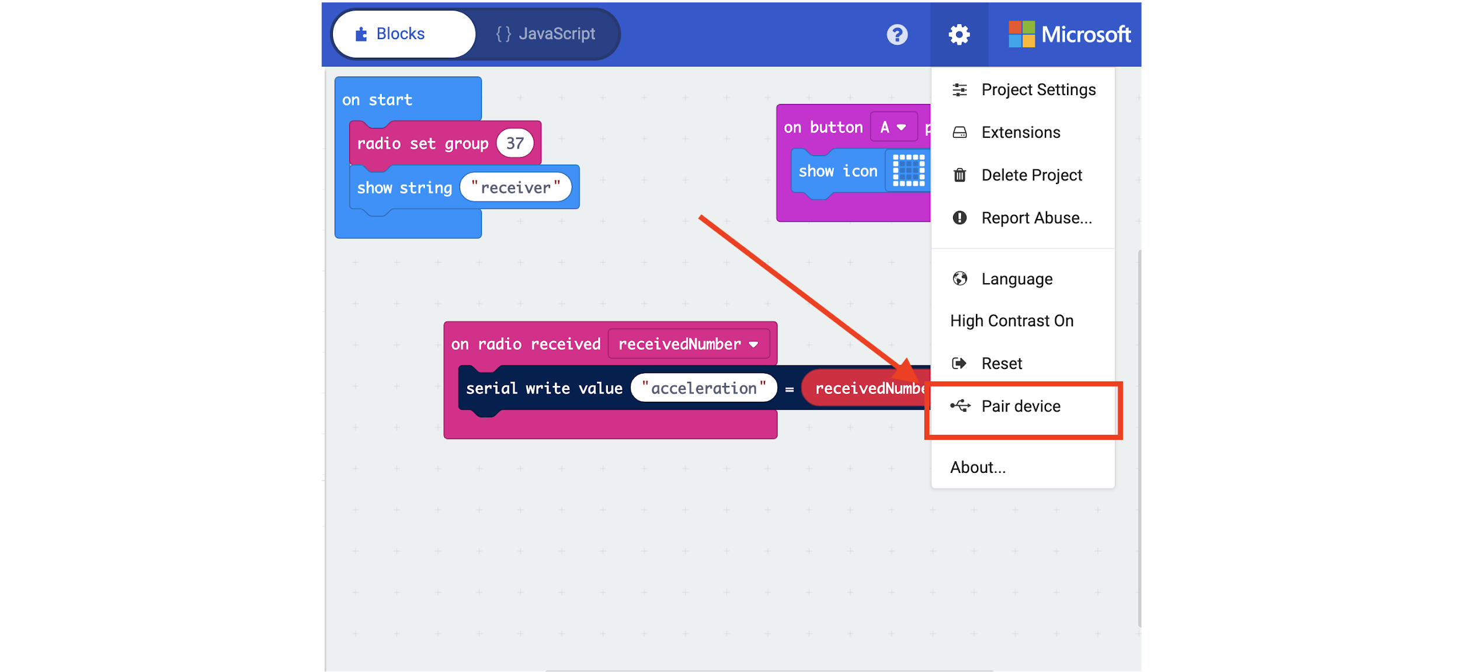
3. 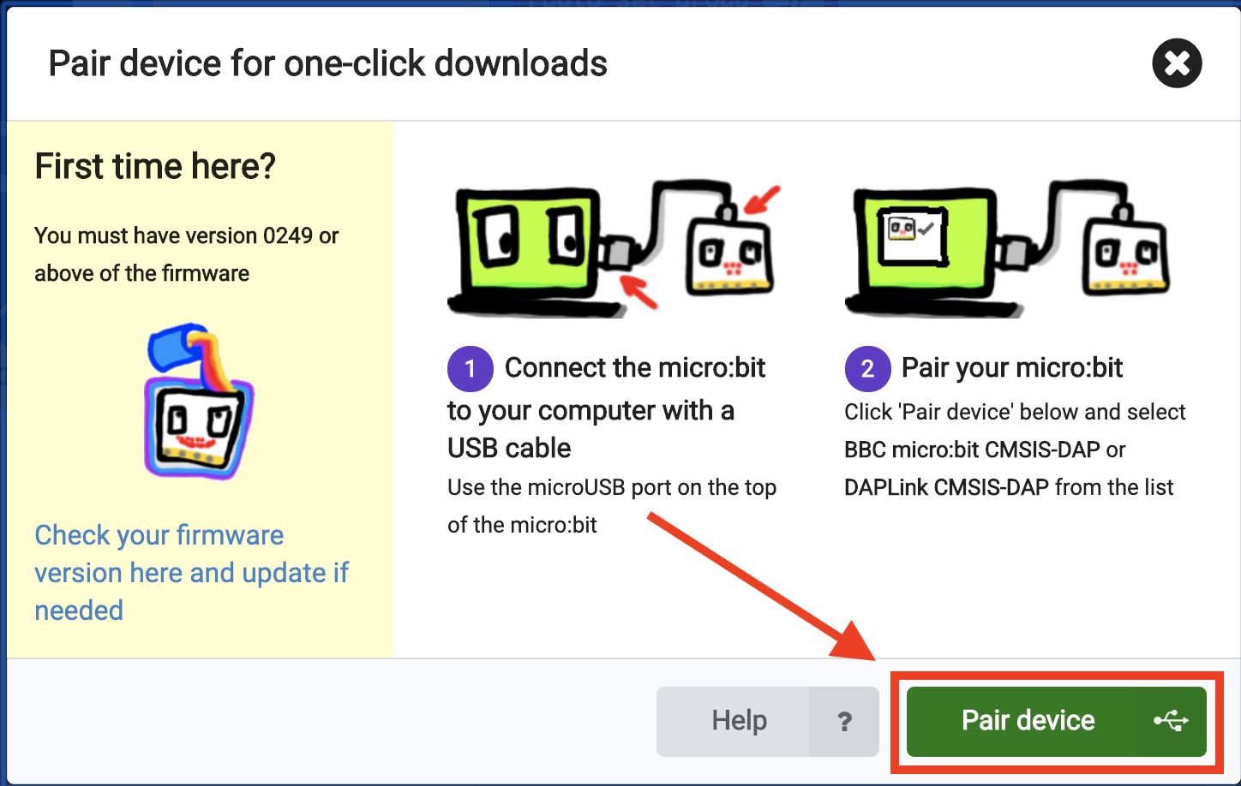
4. 
5. 

The code should now be flashed on the micro:bit!

**Step 8:** Attach the transmitting micro:bit to a powerpack and then unplug the transmitting micro:bit

**Step 9:** Plug in a new micro:bit which will be programmed as the receiving micro:bit

1. Make a piece of code to test that the file gets loaded (ex: an image or string appearing on the screen if the ‘A’ or ‘B’ button is pressed)



1. Make a piece of code that establishes the radio group that the sensor information will be transmitted through (it is important that every student group choose THE SAME GROUP that they chose for the transmitting micro:bit) as well as an optional string that will let you know upon starting up your micro:bit that it is the receiving micro:bit

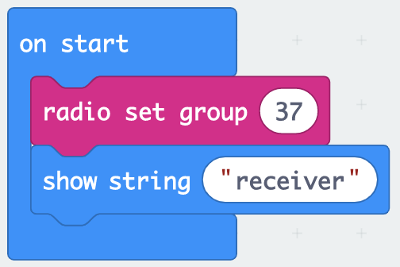

1. Make a piece of code that will be receiving the sensor information being sent over from the transmitting micro:bit



**Step 10:** Save this file with a name you will remember below the coding area

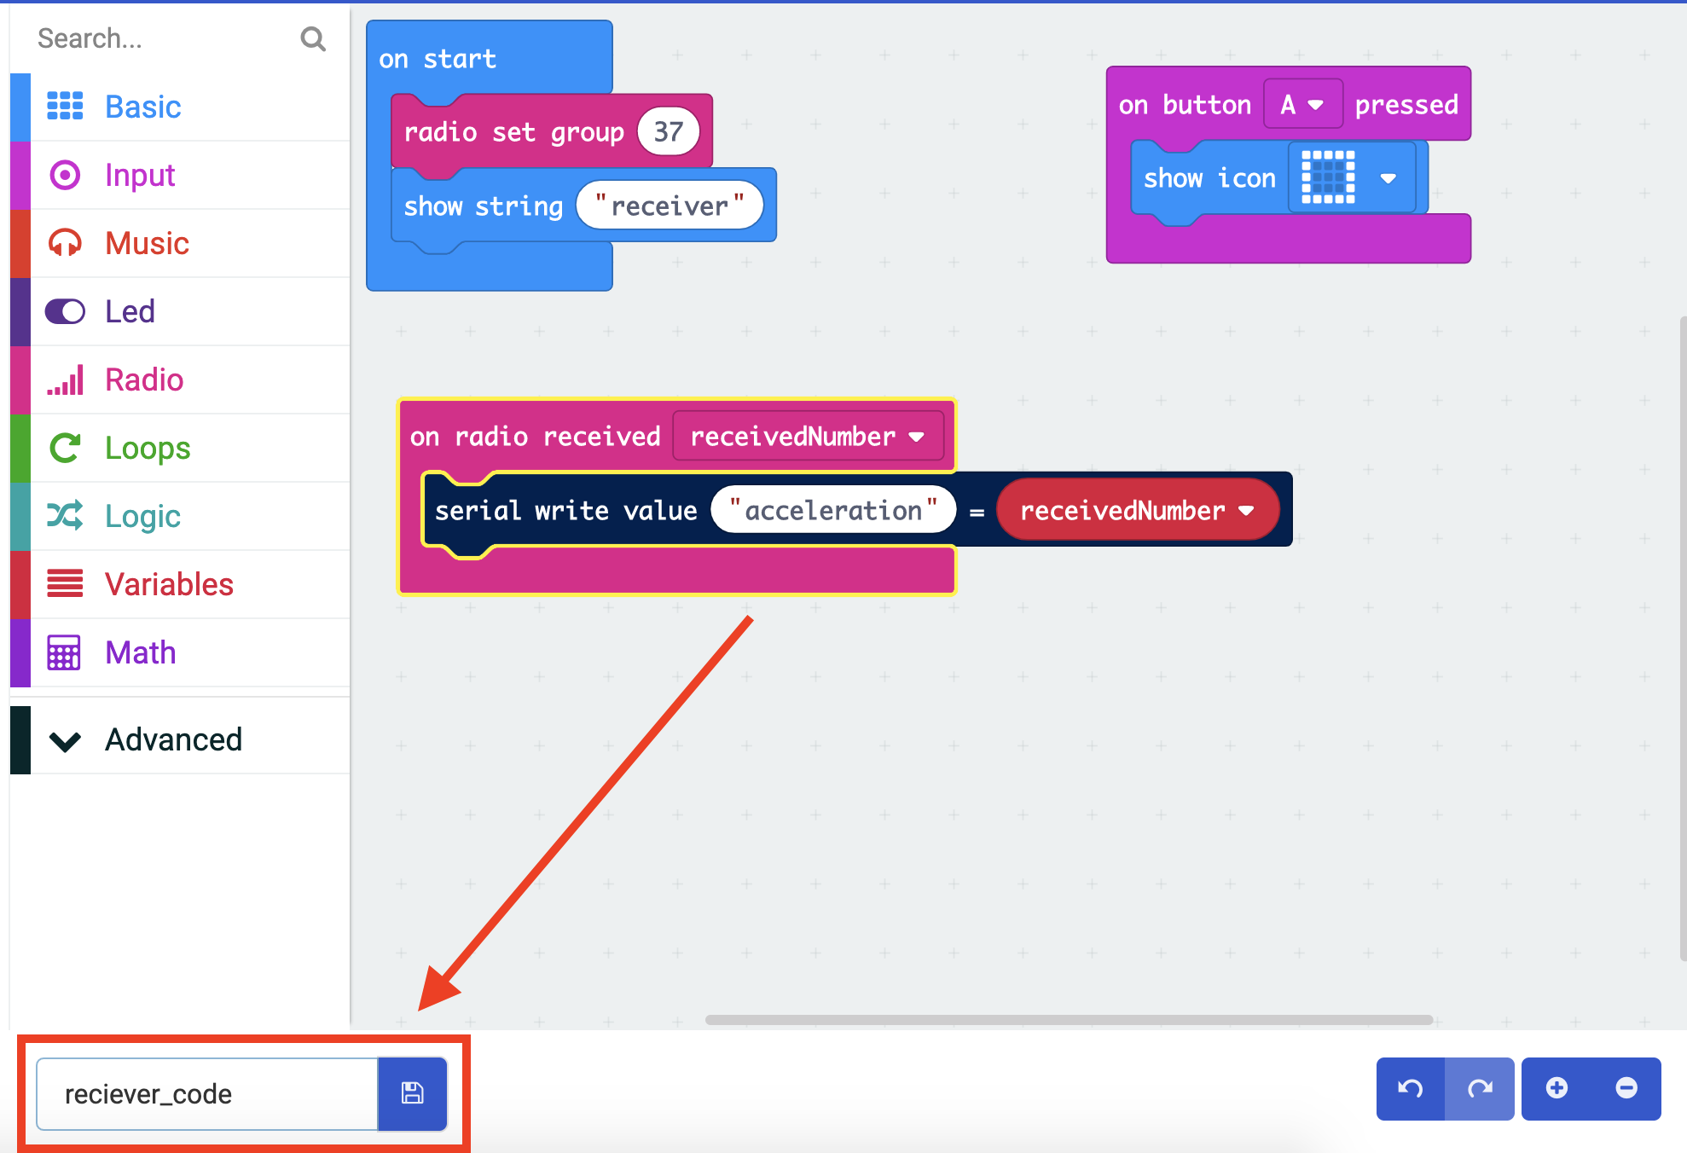

**Step 11:** Follow **Step 7** to pair the micro:bit and download the the file

**Step 11:** Keep this micro:bit plugged into the computer and wait until you see the ‘console’ button under the computer micro:bit

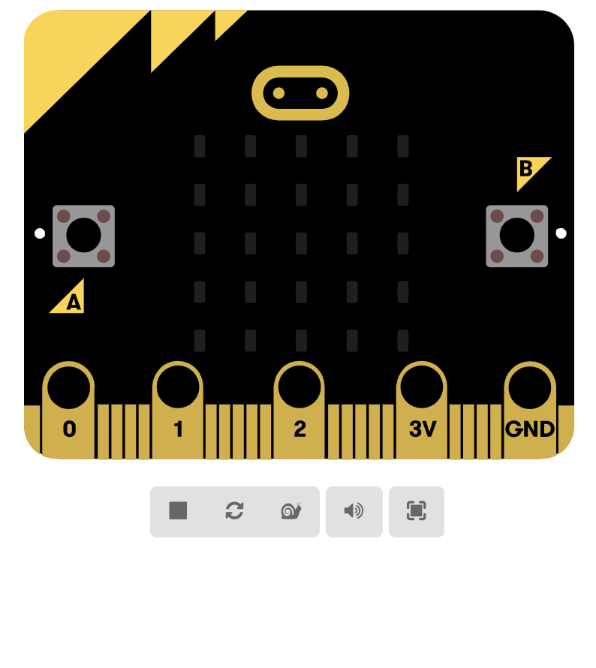



**Step 12:** You can now try and activate the sensor on the transmitting micro:bit and see the the output on the screen! You can also download the files of the information in the lower right corner of the console screen to graph it separately if desired.